PHYSICS 2BPHY

Formulae and constants sheet

2008/16452[v2]



Physics 2B: Formulae and constants sheet

Heating and Cooling

Change of temperature | 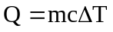
Change of state | 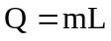
Absolute zero of temperature | 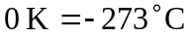
Electrical Fundamentals

Electric current | 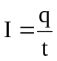
Electric field | 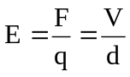
Work and energy | 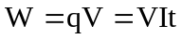
Ohm’s law | 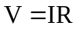
Resistances in series | 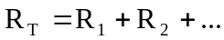
Resistances in parallel | 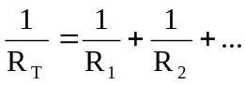
Power | 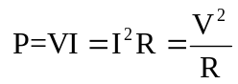
Physical constants
Speed of light in vacuum or air c = 3.00 x 10⁸ m s⁻¹
Tonne 1 tonne = 10³ kg = 10⁶ g

Physical data
Mean acceleration due to gravity on Earth g = 9.80 m s⁻²

Specific Heat of water = 4180 J kg⁻¹ ⁰C⁻¹
Specific Heat of glass = 650 J kg⁻¹ ⁰C⁻¹
Specific Heat of Air = 1000 J kg⁻¹ ⁰C⁻¹
Latent Heat of Fusion of water = 3.36 x 10⁶ J kg⁻¹
Latent Heat of vaporisation of water = 2.25 x 10⁶ J kg⁻¹

Prefixes of the metric system

Factor | Prefix | Symbol | Factor | Prefix | Symbol
10¹²  10⁹  10⁶  10³ | tera  giga  mega  kilo | T  G  M  k | 10⁻³  10⁻⁶  10⁻⁹  10⁻¹² | milli  micro  nano  pico | m  µ  n  p

